Semantic Integrity Constraint Checking for Multiple XML Databases
Praveen Madiraju⁺, Rajshekhar Sunderraman*, Shamkant B. Navathe^, Haibin Wang*
praveen@mscs.mu.edu, raj@cs.gsu.edu, sham@cc.gatech.edu, hwang17@student.gsu.edu
+ Department of Mathematics, Statistics, and Computer Science
Marquette University
P.O. Box 1881, Milwaukee, WI 53201
* Department of Computer Science
Georgia State University
Atlanta GA 30302
^College of Computing
Georgia Institute of Technology
Atlanta GA 30332

Category of Submission: Research Paper
Contact Author: Dr. Praveen Madiraju
Email: praveen@mscs.mu.edu
Phone: 414-288-6340

Semantic Integrity Constraint Checking for Multiple XML Databases
ABSTRACT
Global semantic integrity constraints ensure integrity and consistency of data spanning multiple databases. In this paper, we take initial steps towards representing global semantic integrity constraints for XML databases. We also provide a general framework for checking global semantic integrity constraints for XML databases. Furthermore, we set forth an efficient algorithm for checking global semantic integrity constraints across multiple XML databases. Our algorithm is efficient for three reasons: 1) the algorithm does not require the update statement to be executed before the constraint check is carried out; hence, we avoid any potential problems associated with rollbacks, 2) sub constraint checks are executed in parallel, and 3) most of the processing of algorithm could happen at compile time; hence, we save time spent at run-time. As a proof of concept, we present a prototype of the system implementing the ideas discussed in this paper.
Keywords: Global XML Integrity Constraints, Constraint Checking in XML, XML Databases.

INTRODUCTION
Consider a scenario wherein two or three different companies host XML data (native XML database management system) at different and independent sites. Data at these sites are not necessarily independent, but may participate in a relationship with data from other sites. A single update (XUpdate (Tatarinov et al., 2001), (Laux & Martin, 2000)) on one site might cause a global constraint (global XConstraint) to be violated. By global XConstraints, we mean global semantic integrity constraints affecting multiple XML databases. Hence we need an approach to check for such constraint violations. In the XML database setting, the majority of the times, users are interested in generating (updating), integrating and exchanging data. So, frequent updates on XML data may cause frequent global constraint violations. Hence we need a plan that will efficiently and speedily check for such global constraint violations.
Plan A would be to translate the XML document into relational data using methods such as those found in Shanmugasundaram et al. (1999) and Chen et al. (2003). And then, map the updates and constraints on the XML data to corresponding updates and constraints on the relational data (Chen et al., 2002a). Now the problem of constraint checking on XML data is pushed to the problem of constraint checking on relational data. There are well established models for constraint checking in the relational world. However, this approach suffers from the overhead cost involved in transforming XML data into relational data (Kane, Su & Rundensteiner, 2002). Plan B would be to check for constraint violations on the XML data without transforming to relational data. It should be noted that using plan A vs. plan B depends on the application being considered. If the application contains millions of records and if it benefits to use relational database features such as querying, fast indexing, etc., it is worth while to consider plan A; otherwise plan B suffices for a normal sized application. In this paper, we consider the plan B route.
A brute force approach would first update an XML document and then check for constraint violations. If a constraint is violated, we can rollback. However, such a brute force approach suffers from the overhead of time and resources spent on rollback. Hence, we need an approach that would check for constraint violations before updating the database and therefore obviates the need for rollback situations.
In our constraint checking procedure, constraint violations are checked at compile time, before updating the database. Our approach centers on the design of the XConstraint Checker. Given an XUpdate (Tatarinov et al., 2001), (Laux & Martin, 2000) statement and a list of global XConstraints, we generate sub XConstraint checks corresponding to local sites. Sub XConstraint is an XML constraint, expressed as an XQuery, local to a single site (more details in Section 4). The results gathered from these sub XConstraints determine if the XUpdate statement violates any global XConstraints. Our approach is efficient; since we do not require the update statement to be executed before the constraint check is carried out and hence, we avoid any rollback situations. Our approach achieves speed as the sub constraint checks can be executed in parallel.

Overview of the system
Figure 1 gives the overview of the system. We propose a three-tier architecture.
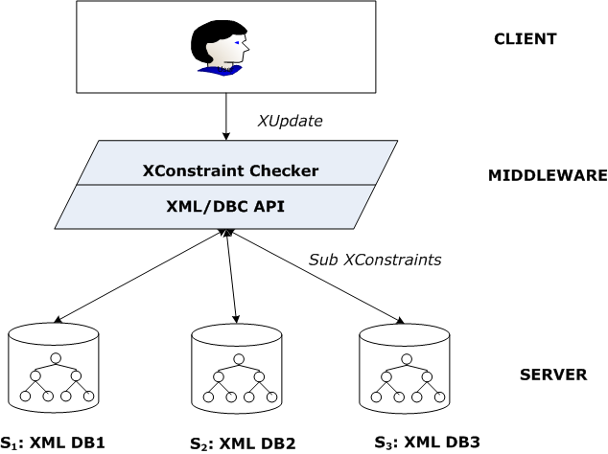
Figure 1: Overview of system (Madiraju et al., 2004)
The server side consists of two or more sites hosting native XML databases. In Figure 1, we show three sites S1, S2 and S3. The client makes an XUpdate request through the middleware. The middleware consists of the XConstraint Checker and the XML/DBC (Gardarin et al., 2002) API. We have earlier (Madiraju et al., 2004) introduced our notations for representing XConstraints and proposed an architecture for XConstraint Checker. One of the important modules in XConstraint Checker is the XConstraint Decomposer. Here, we extend on our earlier work and (i) give the algorithmic description for the XConstraint Decomposer, (ii) illustrate the algorithm with clear examples, and (iii) implement a prototype system. The XConstraint Decomposer takes as input a global XUpdate and a list of global XConstraints and outputs sub XConstraints to be executed on remote sites. XML/DBC (Gardarin et al., 2002) is the standard XML XQuery API that facilitates access to XML based data products. The XML/DBC API consists of two API's: 1) The Java API is a JDBC extension to query XML collections using XQuery. 2) The web services API is designed to provide a SOAP style server interface to clients. In our case, XML/DBC API executes sub XConstraints corresponding to remote sites. The XConstraint Checker gathers results obtained from sub XConstraints and makes a decision whether a constraint is violated. Only in the event of no constraint being violated, the XUpdate statement is executed.
The rest of the paper is organized as follows: In Section 2, we give example XML databases that will be referred to throughout the paper. We also give the syntax of XUpdate language and introduce our notations for defining global XConstraints. In Section 3, we give the internal architecture of the XConstraint Checker. In Section 4, we present the algorithmic description of the XConstraint Decomposer, which decomposes a global XConstraint into a conjunction of sub XConstraints. In section 5, we give implementation details. We compare our work with related work in Section 6 and finally offer our conclusions in Section 7.

PRELIMINARIES
Here we give an example healthcare XML database and explain the notations of XUpdate. We also introduce our notation for defining XConstraints.

Example Database
Consider a sample healthdb.xml represented in a tree form in Figure 2. Figure 2 gives the logical representation of the HEALTHDB XML databases. Physically, information is distributed across multiple sites:
Site S1: PATIENT information such as SSN (primary key), PName and HealthPlan is stored. CASE information with CaseId (primary key – like a sequence number), SSN, and InjuryDate is also stored.
Site S2: patient’s CLAIM information such as CaseId (primary key), ClaimDate, Amount and Type is recorded.
Site S3: TREATMENT information such as CaseId (primary key), DName (doctor name), TDate (Treatment Date), and Disease is stored.
Note that a patient can suffer multiple injuries uniquely identified by their CaseId at Site S1, and can also make multiple claims identified by their CaseId at site S2.
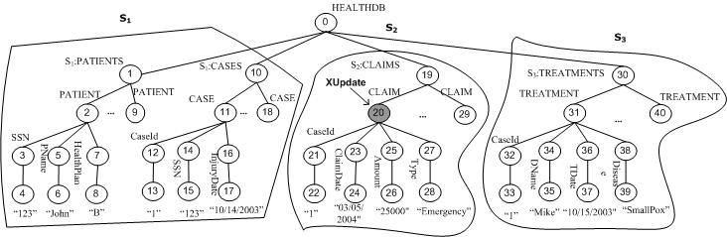
Figure 2: Tree representation of healthdb.xml

XUpdate
XUpdate is the language extension to XQuery to accommodate insert, replace, delete and rename operations. Tatarinov et al. (2001) gives the XUpdate language syntax and semantics. For purpose of better presentation, we give brief description and syntax of XUpdate. The syntax of XUpdate is given below.
FOR $binding1 IN XPath-expr, ...
LET $binding: = XPath-expr, ...
WHERE predicate1, ...
updateOP, ...
where updateOP is defined in EBNF as :
UPDATE $binding { subOP {,subOP}* }
where subOP is defined as :
DELETE $child |
RENAME $child TO name |
INSERT content [BEFORE | AFTER $child] |
REPLACE $child with $content |
FOR $binding IN XPath-subexpr, ...
WHERE predicate1, ... updateOP
The semantics of the FOR, LET, WHERE clauses (FLW) are taken from XQuery, while the updateOP clause specifies a sequence of update operations to be executed on the target nodes identified by FLW clause. Here, we note that, in our context, the XPath-expr from the FOR clause can only refer to nodes from a single site, restricting the updates to only a single site. This is a reasonable assumption, as an XUpdate on a single site might cause one or more global XConstraints to be violated and we want to check for such constraint violations at compile time (before the XUpdate is executed). Below, we show a sample XUpdate occurring on the XML tree (node 20) of Figure 2.
FOR $cl in document("healthdb.xml")/HEALTHDB/S2:CLAIMS
UPDATE $cl
{
INSERT <CLAIM>
<CaseId>1</CaseId>
<ClaimDate>03/05/2004</ClaimDate>
<Amount>25000</Amount>
<Type>Emergency</Type>
</CLAIM>
}
For a detailed description of the XUpdate language, readers are referred to Tatarinov et al., (2001) and Laux and Martin (2000).

XML Constraint Representation
Semantic integrity constraints can be considered as a general form of assertions. They specify a general condition in the database which needs to be true always. Constraints of this type deal with information in a single state of the world. Throughout the paper, we denote semantic integrity constraints for XML database as XConstraints. Global XConstraints are the constraints spanning multiple XML databases. Here we give the constraint representation for global XConstraints.
A datalog rule (expressed as Head ← Body) without a Head clause is referred to as a denial. It is customary to represent integrity constraints in the logic databases as range restricted (safe or allowed) denials.
Definition 2.1: In order to represent global XConstraint in the context of XML database as query evaluation, we consider global XConstraint in the form of range restricted denials (datalog style notation) given below:
C ← X1 ^ X2 ^,…, Xn , where C is the name of the global XConstraint and each Xi is either an XML literal or Arithmetic literal. ▄
We define both XML literal and arithmetic literal below. The definition of XML literal is chiefly inspired by Buneman et al. (2001) and Chen et al. (2002a). Semantics for representing key constraints for a single XML database are given in Buneman et al. (2001) and Chen et al. (2002a). We extend their semantics by introducing user defined variables, term paths and XML literals for representing global XConstraints for multiple XML databases.
Definition 2.2: An XML literal is defined as follows:
X_{i} : (Qi , (Qi' , [ Vi1 = ti1 , Vi2 = ti2 ,…, Vik = tik ] ) )
Using the syntax from (Buneman et al., 2001), (Chen et al., 2002a), Qi , Qi' and ti1, ti2 ,…, tikare path expressions corresponding to Xi . Vi1, Vi2 ,…, Vik are user defined variables corresponding to ti1, ti2 ,…, tik. Qi is called the context path, Qi' the target path and ti1, ti2 ,…, tikare the term paths. Context path Qi identifies the set of context nodes, с and for each с, Vi1, Vi2 ,…, Vik are the set of user defined variables corresponding to the term paths, ti1, ti2 ,…, tik reachable from с via Qi'. ▄
Definition 2.3: Arithmetic literal is defined as: expression θ expression, where expression – is a linear expression made of variables occurring in XML literals, integer constants, and the four arithmetic operator +, -, *, /; θ – is a comparison operator (=, <, >, <=, >=, <>). Joins between nodes are expressed either as an equality (=) between two variables in an arithmetic literal or by having the same variable name appear in different XML literals within the same global XConstraint. Note that variables with the same name cannot appear in the same XML literal. ▄
Now, we are ready to define the satisfiability of a global semantic integrity constraint (global XConstraint), C.
Definition 2.4: An XML tree T is said to satisfy a global integrity constraint (global XConstraint), C, if and only if the conjunction of X1, X2 ,…, Xn evaluates to false ▄
The motivations behind using our constraint representation and negative semantics for checking the satisfiability of a global semantic integrity constraint are: 1) constraint representation using our approach resembles query evaluation for heterogeneous databases (logic, relational, XML) and hence is very generic due to the inherent logic based approach used in representing the XConstraints. 2) Global XConstraints decomposed using Algorithm 4.1 (Section 4) are much easier using our XConstraint representation, as the sub XConstraints generated are XQueries evaluated against local database and can return a true/false. Hence the overall conjunction (which is also true/false) of sub XConstraints determines the satisfiability of a global XConstraint.
Note that each Qi ,Qi', user defined variables and the term paths corresponding to each XML literal - Xi has the site information referred to as Sj and can only refer to a single site. However, a global XConstraint has one or more XML literals and hence can refer to multiple XML databases. In case of Arithmetic literal, expression θ expression, the variables in the expression could belong to different sites. If two variables are not the leaf nodes, the equality join among the two variables is similar to the node equality considered in (Buneman et al., 2001).
Example 2.1: Consider two global XConstraints C1 and C2 defined on healthdb.xml. Constraint C1 states that a patient with HealthPlan ‘B’ diagnosed with ‘SmallPox’ may not claim more than 40000 dollars. Constraint C2 states that a patient with HealthPlan ‘B’ may not file a claim of type ‘Emergency’.
C1:-
(//S1:PATIENTS,
(./PATIENT,[ssn=./SSN,healthplan=./HealthPlan])),
(//S1:CASES,(./CASE,[caseid=./CaseId,ssn=./SSN])),
(//S2:CLAIMS,(./CLAIM,[caseid=./CaseId,amount=./Amount])), (//S3:TREATMENTS,
(./TREATMENT,[caseid=./CaseId,disease=./Disease])),
healthplan = 'B',disease = 'SmallPox',amount > 40000.
C2:-
(//S1:PATIENTS,
(./PATIENT,[ssn=./SSN,healthplan=./healthplan])),
(//S1:CASES,(./CASE,[caseid=./CaseId,ssn=./SSN])),
(//S2:CLAIMS,(./CLAIM,[caseid=./CaseId,type=./type])),
healthplan = 'B',type = 'Emergency'.
For the example contained in Figure 2, C1 is satisfied, but C2 is violated. C1 is satisfied for the healthdb.xml as one of the arithmetic literals amount (node 25, value = 25000) > 40000 returns false and hence the whole conjunction for C1 evaluates to false. C2 is violated as the conjunction for C2 evaluates to true. Arithmetic literal, healthplan (node 7, value = 'B') = 'B' evaluates to true and similarly, type (node 27, value='Emergency') = 'Emergency' evaluates to true and hence the whole conjunction for C2 evaluates to true.
We also note that keys introduced in (Chen et al., 2002a), can be expressed using our representation. Consider a key constraint, C3, which states that within the context of PATIENTS, a PATIENT is uniquely identified by SSN. Using the notation of (Chen et al., 2002a), C3 can be expressed as follows:
C3:- (/HEALTHDB/S1:PATIENTS,(./PATIENT,{./SSN}))
A key constraint such as C3 could be expressed in our notation (a functional dependency) as two XConstraints:
C31:-
(//S1:PATIENTS,(./PATIENT,[ssn=./SSN,name1=./PName])),
(//S1:PATIENTS,(./PATIENT,[ssn=./SSN,name2=./PName])),
name1 <> name2.
C32:-
(//S1:PATIENTS,(./PATIENT,[ssn=./SSN,hp1=./HealthPlan])),
(//S1:PATIENTS,(./PATIENT,[ssn=./SSN,hp2=./HealthPlan])),
hp1 <> hp2.
This has some similarity with the notion of template dependencies (Elmasri & Navathe, 2003), wherein we can represent any general constraints in relations.

XCONSTRAINT CHECKER
We first give the assumptions of the system and then present the detailed architecture of the XConstraint Checker.

Assumptions
XConstraint Checker relies on the fundamental concepts (XConstraint, XUpdate) introduced in Section 2. The assumptions we make for the XConstraint Checker are:
- A restricted set of XUpdate language is considered without losing the generality of the approach. We permit the following SubOP’s: DELETE $child, INSERT content [BEFORE | AFTER $child] and REPLACE $child with $content. The optional [BEFORE | AFTER $child] is applicable for an ordered execution model of XML tree. Also, we restrict the updates to elementary updates. The elementary update considers: (i) updates occurring only on one single node of an XML tree and (ii) updates with only one SubOP at a time. However, note that any update can be equivalently transformed into a set of elementary updates; therefore, we do not lose the generality of the approach.
- XML constraint representation follows from Section 2.3.

XConstraint Checker Architecture
The internal architecture of the XConstraint Checker is presented in Figure 3. The XConstraint checker interfaces with the rest of the system as shown in Figure 1. The XConstraint Checker consists of the following modules.
- XUpdate Parser: parses an XUpdate statement input by the user and identifies the XNode Value List (XNVL), involved in the XUpdate.
- XMetadatabase: stores and acts as a repository of global XConstraints.
- XMeta Extractor: extracts only the global XConstraints being affected by the XUpdate.
- XConstraint Decomposer: decomposes a global XConstraint into a set of sub XConstraints to be validated locally on remote sites.
The overall process of constraint checking is explained in the following four steps (see Figure 3).
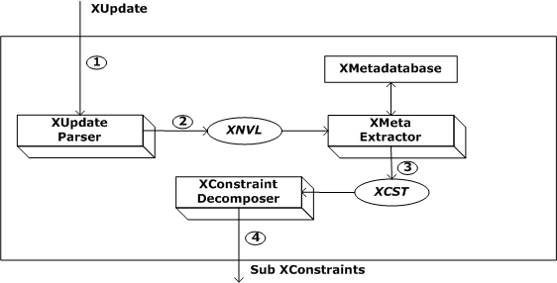
Figure 3: XConstraint checker internal architecture

STEP 1
The user issues an XUpdate statement on one of the sites. Figure 4 gives the initial XML database state before the XUpdate statement is executed. For example, user issues an XUpdate statement, XU1 on site S2.
XU1 =
FOR $cl in document("healthdb.xml")/HEALTHDB/S2:CLAIMS
UPDATE $cl
{
INSERT <CLAIM>
<CaseId>1</CaseId>
<ClaimDate>03/05/2004</ClaimDate>
<Amount>25000</Amount>
<Type>Emergency</Type>
</CLAIM>
}
Figure 5 gives the modified tree representation of the healthdb.xml, if the update is successful. The nodes affected by the XUpdate are shown in filled circles.
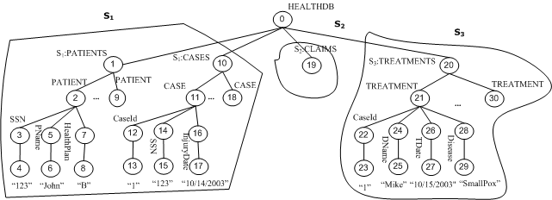
Figure 4: Tree representation of healthdb.xml before XUpdate
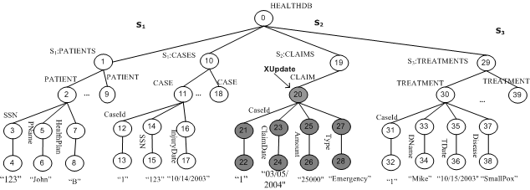
Figure 5: Modified tree representation of healthdb.xml, if XUpdate is successful
STEP 2 (XUpdate Parser)
The XUpdate Parser parses the given XUpdate statement and identifies the XML node being modified. The output from this step is the XML Node Value List (XNVL).
XNVL = N(a1=v1,a2=v2,…,an=vn), where N is the node being updated and is obtained from the $binding in the XUpdate syntax, v1,v2,…,vn are the values being updated corresponding to the attributes a1,a2 , … ,an. a1,a2, …,an are either the XML sub elements or XML attributes being updated and are obtained from the content of the XUpdate statement (Section 2.2). For the running example,
XNVL = {/HEALTHDB/S2:CLAIMS/CLAIM( CaseId = 1,
ClaimDate = '03/05/2004', Amount = 25000,
Type='Emergency')}
STEP 3 (XMeta Extractor)
Let XU↓ denote the path involved in executing the XUpdate statement, XU on the XML tree T. Similarly, C↓ denotes the path in defining the constraint C. We say that an XUpdate, XU might violate a constraint C if, XU↓ ∩ C↓ is not empty. For the running example, XU1↓ corresponds to the following nodes: {20,21,22,23,24,25,26,27,28}, C1↓ matches {3,4,7,8,12,13,14,15,21,22,25,26, 31,32, 37,38} and C2↓ matches {3,4,7,8,12,13,14,15,21,22,27,28} (refer to Figure 5). XU1 ∩ C1↓ is not empty and XU1 ∩ C2 is also not empty; hence, both the constraints might be violated by the update statement. If a global schema or a global DTD is given, we can identify the list of global XConstraints that might be violated by simply consulting the global DTD. The XMeta Extractor identifies the list of constraints being affected by the XUpdate and constructs the XConstraint Source Table (XCST). XCST(Ci) = < Ci, list(Sj)>, where Ci is the constraint identifier and list(Sj) is the list of sites being affected by Ci. For the running example, XCST is given in Figure 6. The XMeta Extractor sends the XCST to the XConstraint Decomposer.
Ci | list(Sj)
C1 | (S1,S2,S3)
C2 | (S1,S2)
Figure 6: XCST
STEP 4 (XConstraint Decomposer)
The XConstraint Decomposer generates the set of sub XConstraints, Cij on the basis of locality of sites. Cij is the sub XConstraint corresponding to constraint - Ci and site - Sj. We present the algorithmic description of generating Cij’s in the next section. For the running example, C11, C12, C13, C21 and C22 are generated. The values of the sub XConstraints are also given in the next section.

XCONSTRAINT DECOMPOSER
The basic idea of XConstraint Decomposer is to decompose a global constraint into a conjunction of sub XConstraints, where each conjunct represents the constraint check as seen from each individual site. Given an XUpdate statement, a brute force approach would be to go ahead and update the XML document and then check for constraint violations. However, we want to be able to check for constraint violations without updating the database. In other words, the XUpdate is carried out only if it is a non constraint violator. Thus, we avoid any potential rollbacks.
Our idea here is to scan through a global XConstraint Ci, XUpdate U and then generate a conjunction of sub XConstraints, Cij’s. The value of each conjunct (each Cij) is either false or true. If the overall value of conjunction is true, constraint Ci is violated (from Theorem 4.1).
Algorithm 4.1 gives the constraint decompositions (Cij’s) corresponding to a global constraint Ci and an XUpdate statement involving an insert statement. Algorithm 4.1 takes as input XML Node Value List, XNVL (STEP2, Section 3.2) and XConstraint Source Table - XCST (STEP3, Section 3.2) and gives as output the sub XConstraints. XNVL (line 1) identifies the node N being inserted with the values v1…vn corresponding to attribute names, a1...an (similar to XUpdate syntax). The update is occurring on site Sm. The outer for loop variable i (line 4) loops through all the constraints C1…Cq affected by the XUpdate. The inner for loop variable j (line 5) loops through each site < (S11,S12,…,S1n),…,(Sq1,Sq2,…,Sqn)> for each constraint Ci. Inside the for loop (lines 4-28), all the sub constraints Cij’s are generated. X1…Xr (line 6) denotes vector of user defined variable v = path expression t in an XML literal (Definition 2.2). Q1.Q1' (line 8) denotes the conjunction of path expressions Q1 and Q1'. A critical feature of the algorithm is the generation of intermediate predicate, IP (line 18). IP’s are generated only at the site where update is occurring. For each variable that occurs in a different site, we generate IP. Conceptually, IP denotes information that needs to be shared from a different site; implementation wise, IP is an XQuery returning the value of the variable from a different site. IPikd means the dth intermediate predicate corresponding to constraint Ci and site Sk.
Algorithm 4.1
1: INPUT : (a) XNVL = $S_{m}:N(a₁=v₁,a₂=v₂,…,a_{n}=v_{n}) on XML tree T
// Note: insert is occurring on Site S_{m}
2: (b) XCST = < <C₁,(S₁₁,S₁₂,…,S_{1n})>,…,<C_{q},(S_{q1},S_{q2},…,S_{qn}> >
3: OUTPUT: list of sub XConstraints <C_{i1},C_{i2},…,C_{ik}> for each C_{i} affected by XUpdate, XU
4: for each i in {1…q} do
5: for each j in {1…n_{i}} do
6: let S_{j}:(Q₁,(Q₁',[X₁] ) ),…, S_{j}:(Q_{r},(Q_{r}',[X_{r}] ) ) be XML literals and A be all arithmetic literals
associated with S_{j}
7: if (j <> m) then
8: C_{ij} = for $var₁ in document(“T”)Q₁.Q₁' ,
9: for $var₂ in document(“T”)Q₂.Q₂', …,
10: for $var_{r} in document(“T”)Qr.Qr'
11: where <cond1>
12: return 1
13: <cond1> is obtained by joining variables with same name appearing in
XML literals and including any arithmetic conditions
14: else if (j = m) then /* site where update is occurring */
15: if (there exists variables in A that do not appear among X₁…X_{r}) then
16: for each variable, ν in A that do not appear among X₁…X_{r} do
17: let k be the site where ν appears as one of the XML literals, ( S_{k}:Q( Q'[X] ) )
18: IP_{ikd} = for $ν in document (“T”)Q.Q'
19: where <cond2>
20: return {$ν /t_{ν} }
21: t_{ν} is the path expression corresponding to $ν in XML literal and <cond 2> is obtained from
X₁…X_{r} and X and d is the nth intermediate predicate
22: end for
23: end if
24: C_{ij} = return 1 if (<cond3> and A') else return 0
25: <cond3> is obtained from XNVL and (logical and) X₁…X_{r}
A' is A with IP’s replacing corresponding variables in A
26: end if
27: end for
28: end for
Theorem 4.1: The conjunction of sub XConstraints, Cij’s generated from Algorithm 4.1 conclusively determines if an XUpdate statement violates a global XConstraint, Ci.

Proof sketch:
- Given an XUpdate statement occurring on site Sm and a global constraint Ci, Ci can be written as conjunction of XML literals and arithmetic literals. If the whole conjunction evaluates to false, Ci is satisfied (from Definition 2.4).
- Each sub XConstraint Cij needs to achieve the exact same result as the XML literal and Arithmetic literals corresponding to site Sj.
- At this point Cij falls in one of the two cases depending on the site Sj :
Case 1: (j <> m) - This is the case where C_{ij} corresponds to a site other than where update is occurring. The generation of C_{ij} in this case involves computing appropriate join conditions and applying arithmetic conditions on XML literals and Arithmetic literals associated with S_{j}. Hence C_{ij} naturally achieves the exact same result as the XML literals and Arithmetic literals associated with S_{j}.
Case 2: (j = m) - This is the case where Cij corresponds to the site where update is occurring. The generation of Cij in this case consists of two parts. Part 1 consists of information from the same site Sj – trivial case (just like Case 1). Part 2 consists of acquiring information from a different site. For each such variable, a unique intermediate predicate is generated. IP’s are XQueries that return the values of such variables by computing appropriate joins and arithmetic conditions involved with such variables. Hence, IP’s guarantee correct information exchange from a different site. The reason we generate unique IP’s is we can either store all the IP’s at a global directory such as the XMeta database or we can generate IP’s at run time.
From steps 2 and 3 we observe that the conjunction of sub XConstraints Cij’s, entails the global XConstraint, Ci. Hence, if Ci determines whether an XUpdate violates the constraint, then conjunction of its Cij’s also determines if the constraint Ci is violated. In other words, if the whole conjunction of Ci evaluates to false, constraint Ci is not violated, otherwise Ci is violated. ▄

Example 4.1
We illustrate working of the algorithm on a sample healthdb.xml (refer to Figure 7), when intermediate predicates are not involved. In Figure 7, we show a patient “John” (with SSN – “123”) is associated with two CaseId’s – 1, 3 and two treatments.
<?xml version="1.0" encoding="UTF-8" standalone="yes"?>
<HEALTHDB>
<!-- S1 indicates site S1 -->
<S1_PATIENTS>
<PATIENT>
<SSN>123</SSN>
<PName>John</PName>
<HealthPlan>B</HealthPlan>
</PATIENT>
<PATIENT>
<SSN>234</SSN>
<PName>Clark</PName>
<HealthPlan>C</HealthPlan>
</PATIENT>
</S1_PATIENTS>
<S1_CASES>
<CASE>
<CaseId>1</CaseId>
<SSN>123</SSN>
<InjuryDate>10/14/2003</InjuryDate>
</CASE>
<CASE>
<CaseId>2</CaseId>
<SSN>234</SSN>
<InjuryDate>06/24/2004</InjuryDate>
</CASE>
<CASE>
<CaseId>3</CaseId>
<SSN>123</SSN>
<InjuryDate>10/12/2004</InjuryDate>
</CASE>
</S1_CASES>
<!-- S2 indicates site S2 -->
<S2_CLAIMS>
<CLAIM>
<CaseId>3</CaseId>
<ClaimDate>11/14/2004</ClaimDate>
<Amount>40000</Amount>
<Type>Inpatient</Type>
</CLAIM>
</S2_CLAIMS>
<!-- S3 indicates site S3 -->
<S3_TREATMENTS>
<TREATMENT>
<CaseId>1</CaseId>
<DName>Mike</DName>
<TDate>10/15/2003</TDate>
<Disease>SmallPox</Disease>
</TREATMENT>
<TREATMENT>
<CaseId>3</CaseId>
<DName>Blake</DName>
<TDate>10/14/2004</TDate>
<Disease>LegInjury</Disease>
</TREATMENT>
</S3_TREATMENTS>
</HEALTHDB>
Figure 7: A sample healthdb.xml document
Consider an XUpdate statement, XU₁ occurring on site S₂.
XU1 =
FOR $cl in document("healthdb.xml")/HEALTHDB/S2:CLAIMS
UPDATE $cl
{
INSERT <CLAIM>
<CaseId>1</CaseId>
<ClaimDate>03/05/2004</ClaimDate>
<Amount>25000</Amount>
<Type>Emergency</Type>
</CLAIM>
}
Applying STEPS 1-4 from Section 3, we obtain
XNVL = {/HEALTHDB/S2:CLAIMS/CLAIM( CaseId = 1,
ClaimDate = '03/05/2004', Amount = 25000,
Type='Emergency')}
CDST (C1) = <C1, (S1, S2, S3)>
where
C1:-
(//S1:PATIENTS,
(./PATIENT,[ssn=./SSN,healthplan=./HealthPlan])),
(//S1:CASES,(./CASE,[caseid=./CaseId,ssn=./SSN])),
(//S2:CLAIMS,(./CLAIM,[caseid=./CaseId,amount=./Amount])), (//S3:TREATMENTS,
(./TREATMENT,[caseid=./CaseId,disease=./Disease])),
healthplan = 'B',disease = 'SmallPox',amount > 40000.
/* C11 is generated from Algorithm 4.1 (lines 7-13) */
C11 = for $var1 in document("healthdb.xml")//S1_PATIENTS/PATIENT,
for $var2 in document("healthdb.xml")//S1_CASES/CASE,
where $var1/SSN = $var2/SSN and $var2/CaseId = 1 and
$var1/HealthPlan = "B"
return 1
/* C12 is generated from Algorithm 4.1 (lines 14-26) */
C12 = return 1 if {1 = 1 and 25000 > 40000}
else return 0
/* C13 is generated from Algorithm 4.1 (lines 7-13) */
C13 = for $var1 in
document("healthdb.xml")//S3_TREATMENTS/TREATMENT
where $var1/CaseId = 1 and $var1/Disease = "SmallPox"
return 1
So, C1 = C11 ^ C12 ^ C13. In this example, C11 = 1(true), C12 = 0(false) and C13 = 1(true). The conjunction of C11, C12 and C13 evaluates to false. Hence the update statement does not violate constraint C1 (from Theorem 4.1)
Similarly,
C21 = for $var1 in document("healthdb.xml")//S1_PATIENTS/PATIENT,
for $var2 in document("healthdb.xml")//S1_CASES/CASE,
where $var1/SSN = $var2/SSN and $var2/CaseId = 1 and
$var1/HealthPlan = "B"
return 1
C22 = return 1 if {1 = 1 and "Emergency" = "Emergency"}
else return 0
So, C2 = C21 ^ C22. In this example, C21 = 1(true), C22 = 1(true). The conjunction of C21 and C22 evaluates to true. Hence the update statement violates constraint C2 (from Theorem 4.1). Note that C2 is defined in Section 2.3.
Example 4.2
Here, we illustrate generation of sub constraints when intermediate predicates are involved. For the example database given in Figure 7, consider C4, which states “A patient’s date of claim may not be earlier than his/her injury date”. Constraint C4 can be expressed as:
C4:- (//S1:PATIENTS,(./PATIENT,[ssn=./SSN])),
(//S1:CASES,
(./CASE,[caseid=./CaseId,ssn=./SSN,idate=./InjuryDate])),
(//S2:CLAIMS,(./CLAIM,[caseid=./CaseId,cdate=./ClaimDate])),
cdate<idate.
We also assume date arithmetic is available for both XConstraints and sub XConstraints represented as XQueries.
Say, an update statement XU2 is occurring on site S2 of the healthdb.xml given in Figure 7.
XU2 =
FOR $claim in document ("healthdb.xml")/HEALTHDB/S2:CLAIMS
UPDATE $claim
{
INSERT <CLAIM>
<CaseId>1</CaseId>
<ClaimDate>09/14/2003</ClaimDate>
<Amount>25000</Amount>
<Type>Emergency</Type>
</CLAIM>
}
Applying STEPS 1-4 from Section 3, we obtain
XNVL = {/HEALTHDB/S2:CLAIMS/CLAIM( CaseId = 1,
ClaimDate = '09/14/2003',Amount = 25000,
,Type='Emergency')}
CDST (C4) = <C4, (S1, S2)>
IP411= for $var1 in document("healthdb.xml")//S1_PATIENTS/PATIENT,
for $var2 in document("healthdb.xml")//S1_CASES/CASE,
where $var1/SSN = $var2/SSN and $var2/CaseId = 1
return $var2/InjuryDate
C42 = return 1 if (1 = 1 and (09/14/2003 < IP411) )
else return 0
C4 = C42. C42 evaluates to true. Hence, C4 is violated (from Theorem 4.1).

Discussion
Algorithm 4.1 considers elementary XUpdate statements involving an insert statement. The elementary XUpdate statements are statements affecting only one node of an XML tree. We do not consider the issue of transactions. Hence, rollbacks caused by failed transactions can not be avoided.
Here, we make an important observation that an XUpdate statement involving a delete can only violate referential integrity constraints, semantic integrity constraints involving aggregate predicates (sum, max, min, avg and count), state transition and state sequence constraints involving aggregate predicates. It does not violate semantic integrity constraints involving arithmetic predicates considered in this paper. XUpdate statement involving a replace can be modeled as a delete followed by insert. Hence, we have presented a complete model for global semantic integrity constraint checking for XML databases with arithmetic predicates under insert/delete/replace statements.
Let m be the number of global constraints, n be the number of sites, and p be the number of tables at the site where update is occurring. The time complexity of Algorithm 4.1 is O (m*n). If we have a template of possible XUpdate statements, note that all the steps of the algorithm can be carried out at compiling time and we can generate sub constraints for each such template. However, at run time, when an actual XUpdate statement is given, a template match can occur and the corresponding sub constraints, which are already decomposed at compile time, can be executed in parallel at the corresponding sites. Hence, the run time complexity is O(p) plus the communication time required for execution at the corresponding sites. If we did not execute sub constraints in parallel, the run time complexity would be O (m*n). Hence, by pushing most of the processing at compile time, we gain efficiency at run time.

IMPLEMENTATION
The XConstraint Checker architecture and Algorithm 4.1 have been implemented using JDK version 1.3 and the system UI is designed using javax.swing package. A prototype of the system implementation is given in Figure 8. The XMetadatabase panel (top left panel) stores global XConstraints and result area (centre panel) displays the results. The XUpdate panel (lower left panel) allows the user to input XUpdate statements and XML database panel (right most panel) shows the xml files of two or more different sites.
The GUI has two buttons, “Decompose” and “XConstraint Check”. When the user clicks “Decompose”, sub XConstraints are generated and displayed in the result area panel, shown in Figure 9. The resulting sub XConstraints need to be executed on their corresponding remote XML database sites using the XML/DBC API (Gardarin et al., 2002), when “XConstraint Check” button is clicked. However, for our system implementation, we are not considering the action of XConstraint Check, as we have not seen a working version of the XML/DBC kind of products. We have checked for the validity of the sub XConstraints by executing them on the Galax XQuery interpreter version 0.3.5 (Fernandez & Simeon, 2003) using the sample healthdb.xml file.

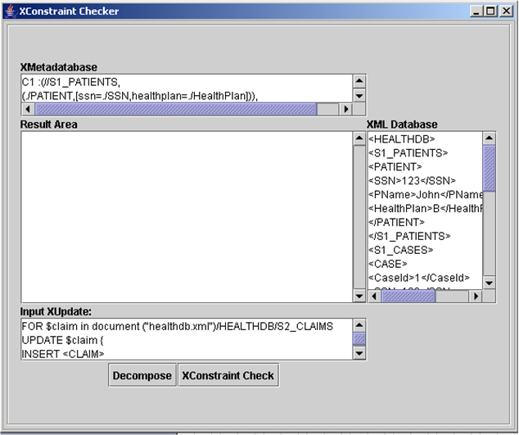
Figure 8: XConstraint checker GUI
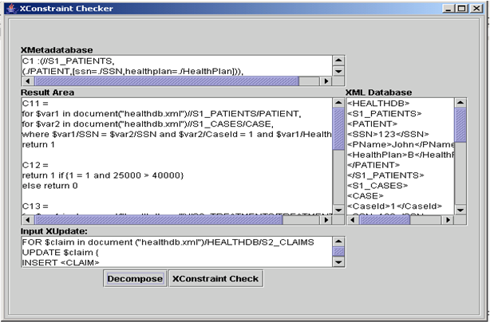
Figure 9: XConstraint checker after decompose

RELATED WORK
Our related work section spans three topics: global constraint checking in relational databases, constraints for XML, and constraint checking in XML.

Global constraint checking in relational databases
Much of the research concerning integrity constraint checking has been done in the area of relational database systems. Grefen & Apers (1993) provide an excellent survey of constraint checking and enforcement methods in relational database systems. Grefen & Widom (1997) give an exhaustive survey of protocols for integrity constraint checking in federated database systems. Gupta & Widom (1993) give approaches for constraint checking in distributed databases at a single site. They show how a class of distributed constraints can be broken down into local update checks. Some of the approaches for distributed databases and federated databases can be easily applied to multidatabases with some minor changes. Ceri & Widom (1993) propose inter-database triggers for maintaining equality constraints between heterogeneous databases. Their approach relies on active rules and assumes a persistent queue facility between sites. Widom & Ceri (1996) mention research on active databases and constraints. Saoudi et al. (1996) give an algorithm for checking extensional constraints on federated schemas.
Grufman et al. (1997) provide a formal description of distributing a constraint check over a number of databases. They propose that the problem of generating sub constraint from a global constraint is the same as rewriting a predicate calculus expression of the constraint check into a form in which the distribution of the data is respected. The rewritten predicate can be seen as a conjunction of sub constraints, where each sub constraint may be visualized as the constraint check as seen from each individual database. During the process of rewriting the constraint check predicate, they introduce the concept of intermediate predicate. The idea of intermediate predicates used in this paper has been borrowed from them. In their constraint distribution model, an update statement is first carried out and the new database state is checked for constraint violation. If the constraint is violated, the update is rolled back. Our work differs from theirs by giving an algorithm that automatically decomposes a global constraint into a conjunction of sub constraints. Our approach is much more sophisticated, as we check for constraint violations with out actually updating the database. The update is executed only when there are no constraint violations. Hence our algorithm is efficient as there are no problems involved with rollbacks as such. Also, Grufman et al. (1997) consider constraint checking in a different context of distributed relational databases.
Ibrahim (2002) proposes a strategy for constraint checking in distributed database where data distribution is transparent to the application domain. They propose an algorithm for transforming a global constraint into a set of equivalent fragment constraints. However, our algorithm coverage is for a different context of multiple XML databases and also we can have different tables on different sites.
Constraints for XML
The idea of keys and foreign keys for XML was introduced in (Buneman et al., 2001), (Chen et al., 2002a). The basic approach is to express constraints using path expressions. We have also studied the constraint representation in distributed databases. In (Gupta & Widom, 1993), a constraint is treated as a query whose result is either false or true. If the query produces false on the database D, D is said to satisfy the constraint. Otherwise, the constraint is violated ((Gupta & Widom, 1993) calls it “panic”). We have extended the approach of (Buneman et al., 2001), (Chen et al., 2002a) with datalog style notations and also used the concepts from (Gupta & Widom, 1993) in representing XConstraints.
Constraint checking in XML
The area of constraint checking for XML is relatively new and very few research results exist in this area. Our approach of constraint checking for multiple XML databases is novel as we have not seen any research on semantic integrity constraint checking for multiple XML databases. Research on validating keys for XML can be found in (Benedikt et al., 2003), (Bouchou et al., 2003) and (Chen et al., 2002b). To our knowledge, the only work closest to ours is SAXE (Kane, Su & Rundensteiner, 2002). SAXE executes only those XUpdates that would preserve the consistency of the XML document with respect to a particular schema. The underlying idea of SAXE is to generate constraint check sub queries. The constraint check sub queries check if the given XUpdate statement violates the consistency of the XML document. The XUpdate statement in SAXE is executed only if it is safe. Hence SAXE avoids any potential rollbacks. We also take a similar route. However, SAXE does not consider semantic integrity constraint checking for multiple XML databases.

CONCLUSIONS
Although native XML databases are not being used very much for commercial purposes, we believe that with the growing popularity of XQuery coupled with efficient storage and indexing techniques for native XML databases, multiple XML databases will be a norm. With this goal in mind, we have presented the architecture of XConstraint Checker. XConstraint Checker is part of a middleware module, which determines if an XUpdate statement violates any global XConstraints. In a nutshell, we have: (i) introduced a notation for representing XConstraints, (ii) proposed architecture for XConstraint Checker, (iii) formalized an algorithm for XConstraint Decomposer, and (iv) implemented a prototype of the system with the ideas discussed in this paper. Given an XUpdate statement and a list of global XConstraints, XConstraint Decomposer (Algorithm 4.1) generates sub XConstraints to be validated locally on remote sites. Since most of the steps of the algorithm can be carried out at compile time, we achieve efficiency at run-time.
We consider semantic integrity constraints with arithmetic literals affecting multiple XML databases. A topic for future work would be to deal with XML constraints with aggregate literals (sum, max, min, avg and count) and arbitrary functions. Also, note that for each global XConstraint that could be violated, multiple sub XConstraints are generated. Hence, we have a large number of sub XConstraints when we consider all the set of global XConstraints. All this process can be done at compiling time. Therefore, efficient ordering of sub XConstraints for executing on remote sites would optimize the constraint checking mechanism. To achieve this, we plan to introduce an XConstraint Optimizer module in the XConstraint Checker.

REFERENCES
Benedikt, M., Chan, C.Y., Fan, W., Freire, J. & Rastogi, R. (2003). Capturing both Types and Constraints in Data Integration. Proceedings of the ACM SIGMOD Conference on Management Of Data

Buneman, P., Davidson, S., Fan, W., Hara, C., & Tan, W. (2001). Keys for XML. World Wide Web, pp.
201-210.

Bouchou, B., Halfeld-Ferrari-Alves, M. & Musicante, M. (2003). Tree Automata to Verify XML Key
Constraints. International Workshop on the Web and Databases.

Ceri, S., & Widom, J. (1993). Managing Semantic Heterogeneity with Production Rules and Persistent Queues. Proceedings of the 19th International Conference on Very Large Data Bases, pp. 108-119.

Chen, Y., Davidson, S.B., Hara, C.S., & Zheng, Y. (2003). RRXF: Redundancy Reducing XML Storage
in Relations. Proceedings of the International Conference on Very Large Databases.

Chen, Y., Davidson, S.B., & Zheng, Y. (2002a). Constraint Preserving XML Storage in Relations.
International Workshop on the Web and Databases.

Chen, Y., Davidson, S.B., & Zheng, Y. (2002b). XKvalidator: A Constraint Validator for XML.
Proceedings of ACM Conference on Information and Knowledge Management.

Elmasri, R.A., & Navathe, S.B. (2003). Fundamentals of Database Systems. Addison-Wesley, 4th edition.

Fernandez, M., & Siméon, J. (2003) .Growing XQuery. European Conference on Object Oriented
Programming (ECOOP).

Gardarin, G., Mensch, A., Tuyet, T., & Smit, D.L.(2002). Integrating Heterogeneous Data Sources with
XML and XQuery. Proceedings of the 13th International Workshop on Database and Expert Systems
Applications.

Grefen, P., & Apers, P. (1993). Integrity Control in Relational Database Systems - An Overview. Journal
of Data and Knowledge Engineering, 10 (2), pp. 187-223.

Grefen, P. & Widom, J. (1997). Protocols for integrity Constraint Checking in Federated Databases.
International Journal of Distributed and Parallel Databases, 5(4): 327-355.
Grufman, S., Samson, F., Embury, S.M., Gray, P.M.D., & Risch, T. (1997). Distributing Semantic
Constraints Between Heterogeneous Databases. Proceedings of International Conference on Data
Engineering

Gupta, A., & Widom, J. (1993). Local Verification of Global Integrity Constraints in Distributed
Databases. Proceedings of the ACM SIGMOD Conference on Management of Data.

Ibrahim, H. (2002). A Strategy for Semantic Integrity Checking in Distributed Databases. Proceedings of
the ninth International Conference on Parallel and Distributed Systems (ICPADS), pp. 139-144

Kane, B., Su, H. & Rundensteiner, E.A. (2002). Consistently Updating XML Documents using
Incremental Constraint Check Queries. Workshop on Web Information and Data Management (WIDM),
Nov, pp. 1-8.

Laux, A., & Martin, L. (2000). XUpdate Working Draft, 2000, last accessed on August 20, 2004
from http://xmldb-org.sourceforge.net/xupdate/xupdate-wd.html

Madiraju, P., Sunderraman, R. & Navathe, S.B. (2004). Semantic Integrity Constraint Checking
for Multiple XML Databases. Proceedings of 14th Workshop on Information Technology and
Systems (WITS 2004), Washington D.C., December, 2004

Saoudi, A., Nachouki, G. & Briand, H. (1996). Checking extensional constraints of federated schemata..
Proceedings of Seventh International Workshop on Database and Expert Systems Applications,
September, pp. 398-403

Shanmugasundaram, J., Tufte, K., He, G., Zhang, C., DeWitt, D., & Naughton, J. (1999). Relational
Databases for Querying XML Documents: Limitations and Opportunities. Proceedingsof the
International Conference on Very Large Databases.

Tatarinov, I., Ives, Z. G., Halevy, A.Y., & Daniel, S. (2001). Updating XML. Proceedings of the ACM
SIGMOD Conference on Management of Data

Widom, J., & Ceri, S. (1996). Active Database Systems: Triggers and Rules for Advanced Database
Processing. Morgan Kaufmann, San Francisco, California.

